/


Zero Feature Release

for

Library information appication

Version: 1.0

Date: 18/05/20

20143692 강경석

20144103 조유성

20145026 김상범

20141043 양준호

20146110 문태현

20143583 김기환

Table of Contents
Index
[Library information appliciation]

Version 1.0

may 17, 2018

1. Documentation FOr users
1.1 description of project
1.2 how a user obatains and install the software
1.3 how to run the software
1.4 description of the user view of software
1.5 how to use the software
1.6 how to report a bug

2. documentation for developers
2.1 how to obtain the source code

2.2 the layout of directory structure

2.3 how to build the software

2.4 how to test the software

2.5 how to set up an automated daily build and test
2.6 how to release a new version of software

2.7 how to access the list of outstanding bugs and the list of resolved bugs, and how to resolve a bug

2.8 source code example

Documentation for Users

A description of project

(1)User perspective

User should change his or her information through updating his or her data. If user's information are changed, he or she should update his or her data . For example, user's ID, password, name birthdate or his or her rental booklist should be changed.
Through this, library administrator can see the updated user data, and update the book's state that whether book exists or not(someone rent the book, or discarded books(no more useful book).
User can secede from library system. For example, user can use another library system, and not wants to leave his or her information no more in library system.
User should find the book that he or she wants to borrow from the library.
Through finding booklist, user can recognize book's state, and that user can know whether book exists that user can rent or not that user cannot rent book from library.
Also, user should know their booklist that they rented books from library.
The reason is that if user know the books that they rented, user can return the books that are already read, or no more useful to user. Also, user can know what book should he or she borrow from library that are not exists in his or her book list.
Finally, user should know whether his or her books are overdue. If their books are overdue, the user of library system measures the late fee from the calculation of days past due, and pay the proper late fee to the library.

(2)Administrator perspective

Administrator should know the library's book list so that administrator can know the book's state in the book list.
For example, administrator can add the new books that are not exist in library book list. Also, administrator should delete the not useful(no more need to user)book from the library book list. Furthermore, administrator should find the specific book that administrator should know the information of specific book.
Administrator should find specific user from library user list. The reason is that
there can be sometimes administrator wants to know the specific user information.
For example, administrator should call user that specific book that user rented is overdue, so user should the some late fee.
To user pay the proper late fee, administrator should know if user's books are over due, and measure the late fee from the calculation of days past due, and let user know through calling user's phone(for this reason, administrator should know user's information)

(3)project plan

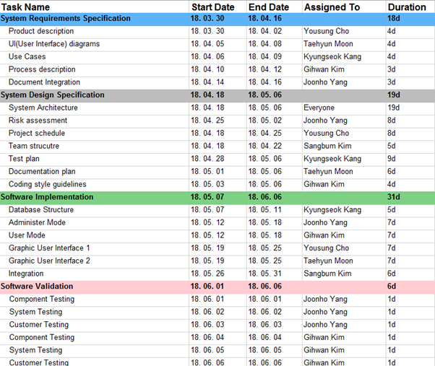

How to obtain and install the software
By using Jsmooth and Window Wrapper, we will change our software to execution file.
We are thinking about to distribute to our customers for free ware by uploading our execution file on personal blog of our manager Taehyun Moon. (https://blog.naver.com/xogus1107)
The customers who downloaded our software need to install JVM that fits in operating system for their computers personally to execute our program.
Distributed execution files can be executed with no other execution processes in the environment that installed JVM.

How to run the software
After installing our program in the computer, you can execute it whenever you want.
Below are processes for executing the software program for Windows and Mac OS environments.

- Microsoft Windows
For executing the program in Windows, double click the execution file or click the icon and press the enter key.

- Mac OS
For executing the program in Mac OS, double click the execution file or click the icon and press the enter key.

A high-level description of the user view of software
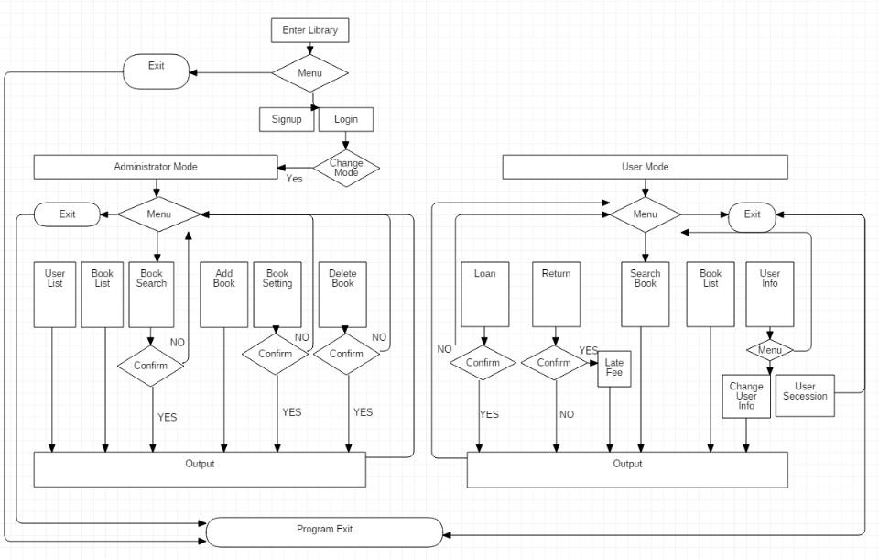
#flow diagram

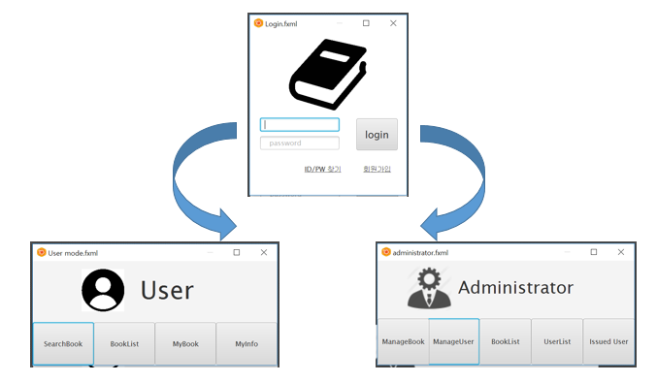
GUI example

How to use the software
The program which is transformed to the executable program by jsmooth will be distributed to the customers in a personal blog. The user will download and use it. The user may double click the icon and login screen like below picture will appear.

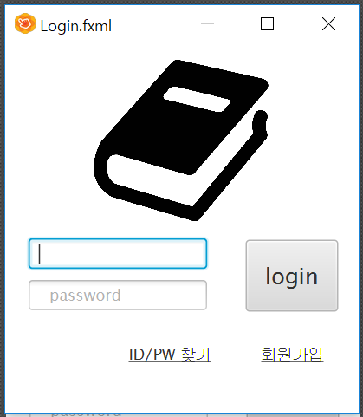

The first-time user may create an account through sign-up (회원가입) button.
After creating an account, the user may login by entering ID and password.
The administrator can enter the administrator mode by using administrator ID.
The user can enter the user mode by using each user ID.

If the administrator login with administrator ID, a screen below will show up.

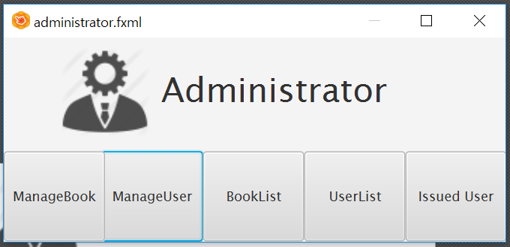

If the administrator click “ManageBook” button, the administrator can add, revise, and delete book information.
If the administrator click “ManageUser” button, the administrator can actually use the function of lending books in the library. This feature specifically change the book status in the book database and the rent_booklist in the user database. Here is example of the lending function GUI.

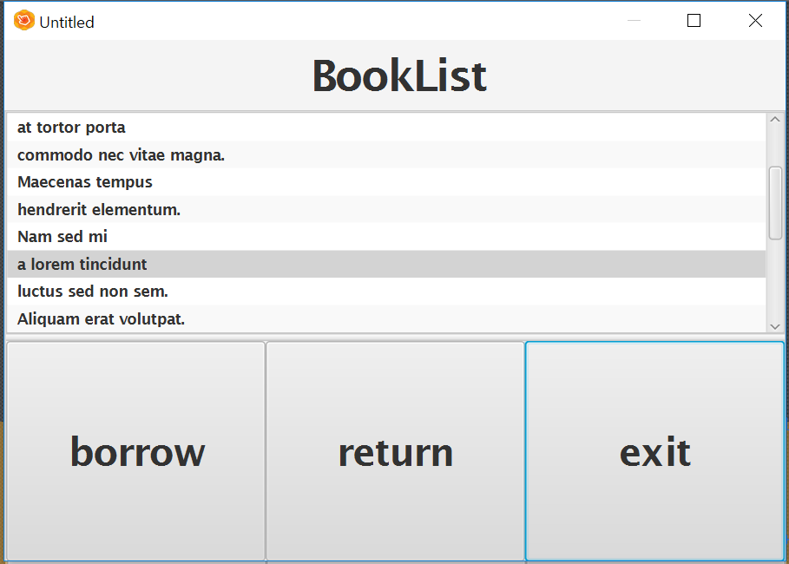

The administrator can revise user’s data in addition.

In the “BookList” and “UserList”, the administrator can see all of the book information and the user list.
Specially, for the effective library management for the administrator, there is a feature of “Issued User”. The “Issued User” will provide the list of users who have to pay late fee.

If the user login with each user ID, a screen below will show up.

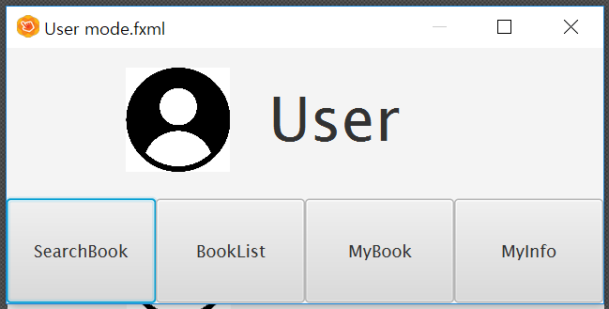

The user basically has “SearchBook” function to search every book in the library.
The “BookList” provides the list of all of the books in the library.
The user may know the list of his or her borrowed books, and the due date and the late fee by clicking the “MyBook” button.
The user may revise the password and the phone number, etc. of the account in the “MyInfo” button.

How to report a bug

Please give a screenshot of the bug that occurred while using the software and a description of the situation at the time on the bug report bulletin board of our project manager’s blog.

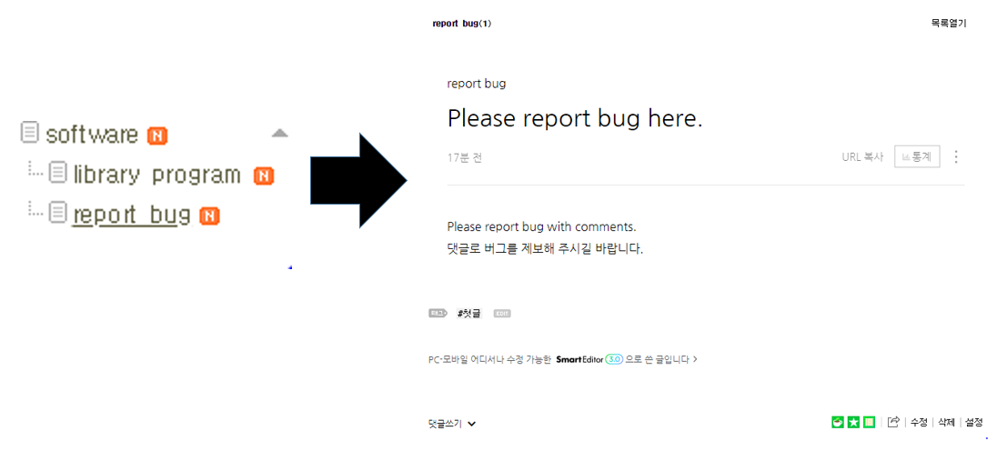

Documentation for developers

How to obtain the (latest) source code

The developers will update and download source codes in the public storage which the project manager made by using web-hosting service “GitHub”.
This public storage will be used for the developers develop functions independently and integrate the functions together when complete.
As well as the public storages, which are a collection of the latest source codes, each developer may create a personal repository and access the repository of another worker even if the source code has problems in his or her repository.

“Github” also allows us to see the history of source code changes, compare to the previous version, move to the specific point of time, and alert us when uploading to a repository if the file you are trying to update conflicts with edits made by other developers. Using these features, we can handle problems made by lots of developers editing the source codes at the same time and manage the most up-to-date codes.

The layout of your directory structure
The public storage of “GitHub” standard

A top-level directory layout | Purpose
build | The compile files are stored inside the build folder
docs | Some reference data in to the project stored into the docs folder.
src | The actual source files of a software project are stored inside the src folder.
test | Automated tests are placed into the test folder.
tools | Supporting tools for this project are stored into the tools folder.

Test Directory | Purpose
test/benchmarks | Load and stress tests
test/integration | Integration tests
test/unit | Unit tests
test/whole | Whole tests

Docs Directory | Purpose
docs/TOC.md | Table of contents
docs/FAQ.md | Frequently asked questions
docs/misc.md | Miscellaneous information
docs/usage.md | Getting started guide

How to build the software
1) Language to use
we will use object-oriented language java to implement the functions of this program divided into class units.

2) Program development tool
To use the java language efficiently we will use eclipse as a program development tool.
Eclipse has a huge plug-in. In the eclipse Plug-in, we will use ‘junit’ to test our program. This test is mentioned in detail below “build and test”.
We use javafx for GUI. Using eclipse can be a great help in linking our program with javafx
And eclipse provede us many libraries, which will benefit program development

3) Functions
The functions of this program will be largely divided into user mode and administrator mode.
It is mentioned in SDS file and this File.

4) GUI
In order to improve user’s convenience and environment, our team will implement GUI using javajx.
There is an example of a GUI that we will implement in “how to use software”.
All the GUI necessary for the program as well as the example above will be implemented using javafx

5) Database
(1) Tool of database
Our team will create a local database with the text.txt file. And we will connect it with program.
When we run and test program, we will prove that our program can effectively manage the database. This means that even if we update the program and link the web database, the program can work efficiently.
(2) Components of database
* User information database : The text file that stores the user database contains the user ID, password, name, birthdate, phonenumber, rent_booklist, code(serial number) and so on.
* Book information database : The text file that stores the book database contains book status(whether it is rental or not), book name, writer, publisher, code(serial number) and so on.

how to test the software

- In unit testing, our team developers can test individual functions in individual modules.
Our library system has 6 modules(Library, Login, Administrator, User, User_Data, Book_Data). So we divided 6 stages to unit test.

In library module, there are seven functions (Library(), main(String[]), inputLogin(), signUp(), Login(), adminLogin(), userLogin()).

First, we isolate all functions in each module. The reason is that our team developers should know whether each function in module work correctly or not.
Then, if error exists in functions in module, we can correct functions.
Through isolating functions in each module, it seems to increase our developing time and cost. However, by reducing the debugging time which takes up most of the development period, it enables the programming to be relaxed.

Also we can reshape code easily without changing the result (refactoring), because after the refactoring, our developers can be sure that our library system's each module works as intended by unit testing.
Our system is bottom up processing, so after unit testing is finished, we can easily integrate functions and modules because they are already tested through unit testing.

- In component testing, where several individual functions are integrated to create each module, we focus on individual module's interfaces to integrate functions.
First, in Login module, there are functions that have roles of interfacing Administrator module and User module (adminLogin(), userLogin()).
Second, in User module, there are three functions that are role of interfacing between User module and User_Data module(user_Change(String), user_Secession(), user_Info(String)).
In User module, these functions update users' data so that User_Data module is renewed.
Also, in User module, there are three functions that are role of interfacing between User module and Book_Data. (book_Search(String), overdue_Calculate(), myBooklist())

In User module, these functions update user's booklist, and show user book's information such as writer, publisher, name, and code.

Third, in Administrator module, there are three functions that have roles of interfacing between Administrator module and User_Data module(overdue_Calculate(), user_Search()), overdue_Calculate() function should count overdue days of specific user, so this function roles interface between User_Data module and Administrator module. user_Search() function should know user's information such as user's book rent list, phone number and name.
Also, in Administrator module, there are five functions that have roles of interfacing between Administrator module and Book_Data module(getBook_List(), book_ADD, book_Setting(String), book_Delete(String), book_Search(String)).
These functions update book lists so, developers should know whether Book_Data module changes. (Renewal of book lists)

- After component testing, in release testing, our developer teams are divided into Administrator mode and User mode in our library system. Each team tests a complete version of Administrator mode and User mode before this program is distributed to the customers.

- After release testing, in user testing, we will provide our complete version of library system to our potential users. Then we will get a feedback from our potential users. We will repeat this stage until our potential users can be satisfied with our library system.

How to set up an automated daily (or more frequent) build and test
1. Our team manage source codes in GitHub. By interlocking GitHub and Jenkins, which is automated build tools, we will build automated daily build environment.
There are 3 things for preparations.
- Jenkins server
- GitHub account
- Project to build in GitHub

Jenkins should build automatically by reading the results automatically pushed by GitHub public storage. In addition, we will set the automated build periodically by 24 hours.

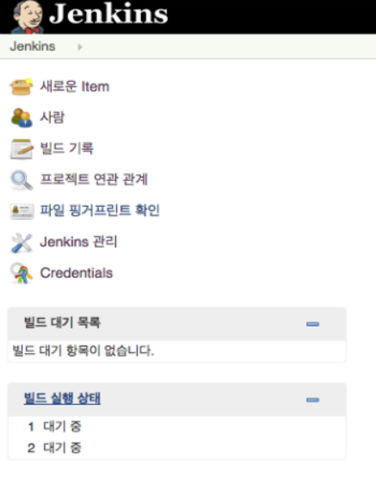

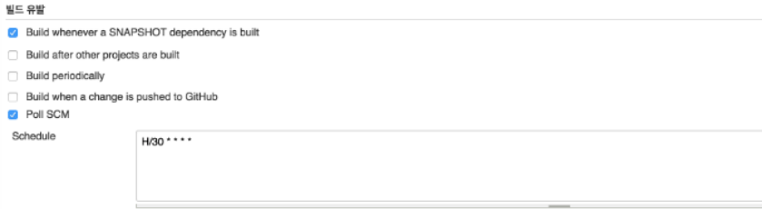

2. We will use JUnit to implement automated test.
JUnit is a unit testing tool. We do not have to debug inconveniently for using system.out by writing external test program(case). It reduces time for program test and it is in Eclipse for plugin form.
The test result does not remain in just a text file, but remains in Test class so that it can produce test methods and the history of class to the developers. Also, simply uninherited Test may be classified as a unit test.
For test classification implement, the settings are like below.

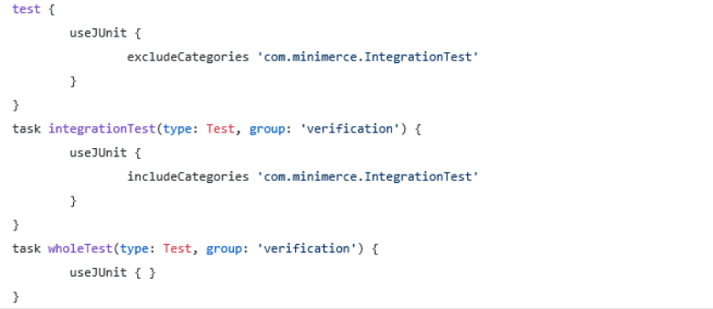

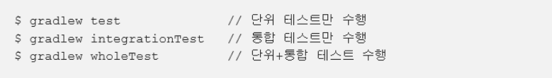

Jenkins, as we said for which is building automated build, supports JUnit plugin.
By using Task implementation shown above, we can run unit testing when source code is added. When source code is distributed, we can set in the time we want to run the test, like the integration or entire test.

How to release a new version of your software

When we think we need improvement in our program or when we get feedbacks from users, our project team will review the content and after the discussion about the improvement of the program, we will design a new version. The designed content will be implemented by the developers using “GitHub” mentioned above. The completed source code is tested through a series of testing, and after the testing process, the code will be converted to an executable file using jsmooth. The new version will be uploaded to the project manager Taehyun Moon’s personal blog (https://blog.naver.com/xogus1107), where has the initial version of the program. Whenever an update to the new version is needed, we will repeat this series of steps and update it on the blog.

How to access the list of outstanding bugs and the list of resolved bugs, and how to resolve a bug
To access the list of outstanding bugs, we decided to notice bug lists in blog that are from comments from Taehyun Moon 's blog.
For example, we will make a table which is consists of bugs, cause, and resolved bug.
Bugs in a table means the bugs that the user experiences a discomfort from.
If bugs that are updated from Taehyun Moon's blog's comments are accumulated , we will notice bug inspection time in Taehyun Moon's blog.
And in that bug inspection time , developers will identify bugs and resolve the bugs.
If we resolve the bug, we will notice table which is consist of bugs, cause and bug.
Cause in a table means what cause the bug during using our library system.
Resolved bugs in a table means the bugs that are resolved in bug inspection time.
If although, we did the effort to resolve the bug, we could not resolve the bug, we will notice the workaround.
Workaround means how to cope with the unresolved bugs.

BUG | CAUSE | RESOLVED BUG | WORKAROUND
#bug table example

The source code(skeleton of program containing explanation, )

1) Library class

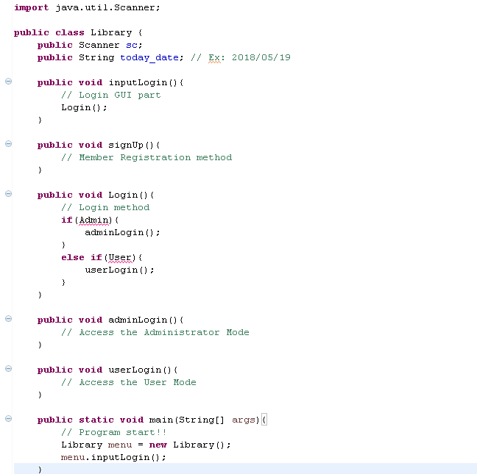

2) Login class

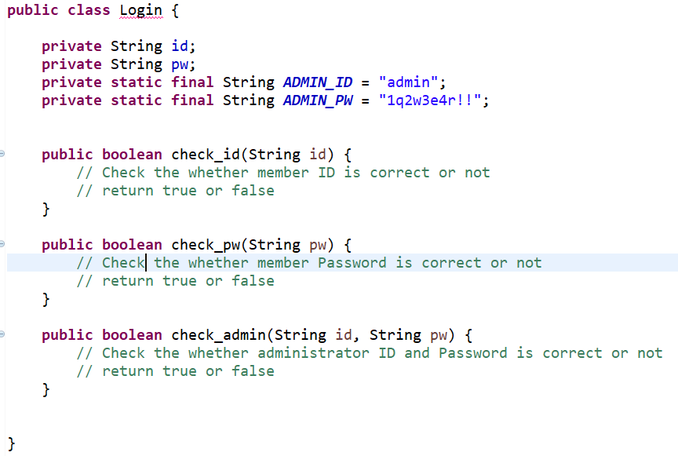

3) User Mode class

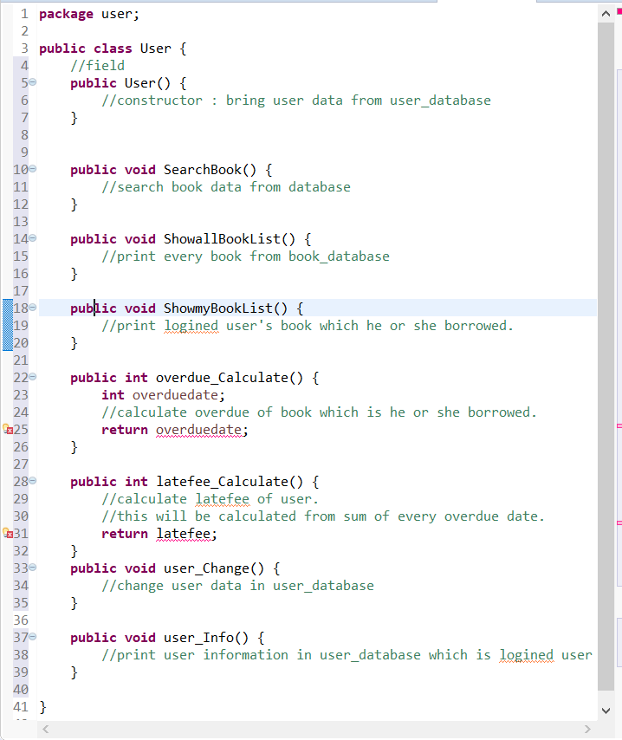

4) Administrator Mode class

